**AWS Lab 7: Introduction to DynamoDB**

Leo Reyes

**Purpose**

The purpose of this lab is to explore DynamoDB tables and explore how to create one as well as how to create objects in the table. This lab will help me explore some of the different features of the tables as well as how the database works with different keys and objects in the table.

**Process**

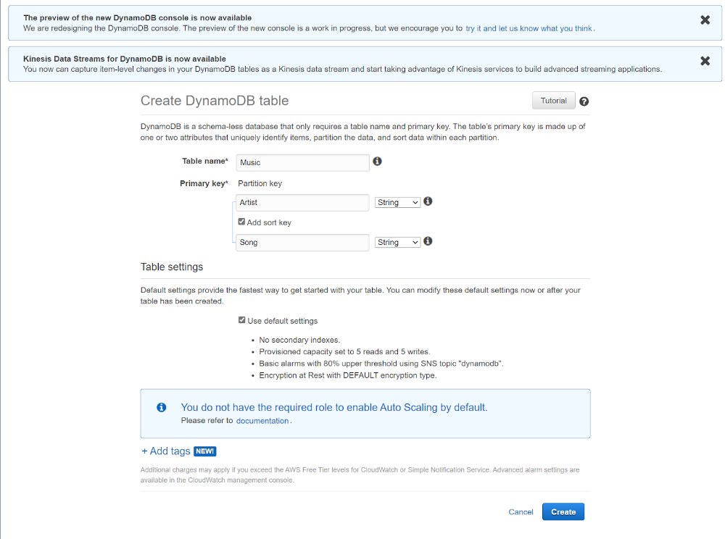

Creating a table is really simple. From the AWS console, you can look up DynamoDB services and after clicking there you can see the create a table option. To create the table, you only need a name for the table and the first settings for the first key which will be the first object in the table.

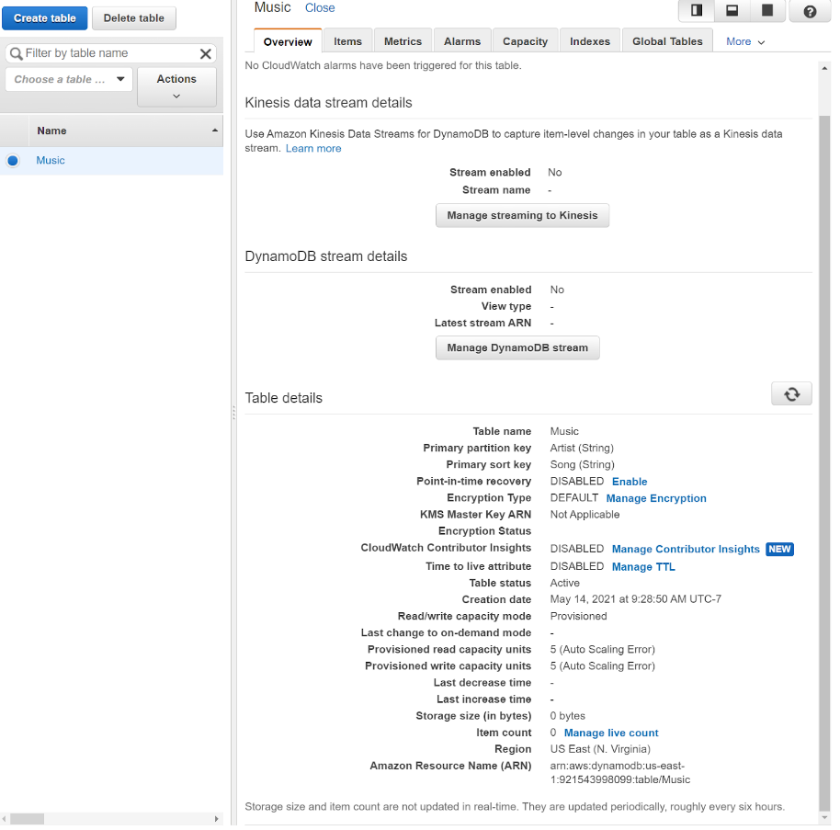

After creating the table with default settings, this will be shown when the table is selected from the DynamoDB service.

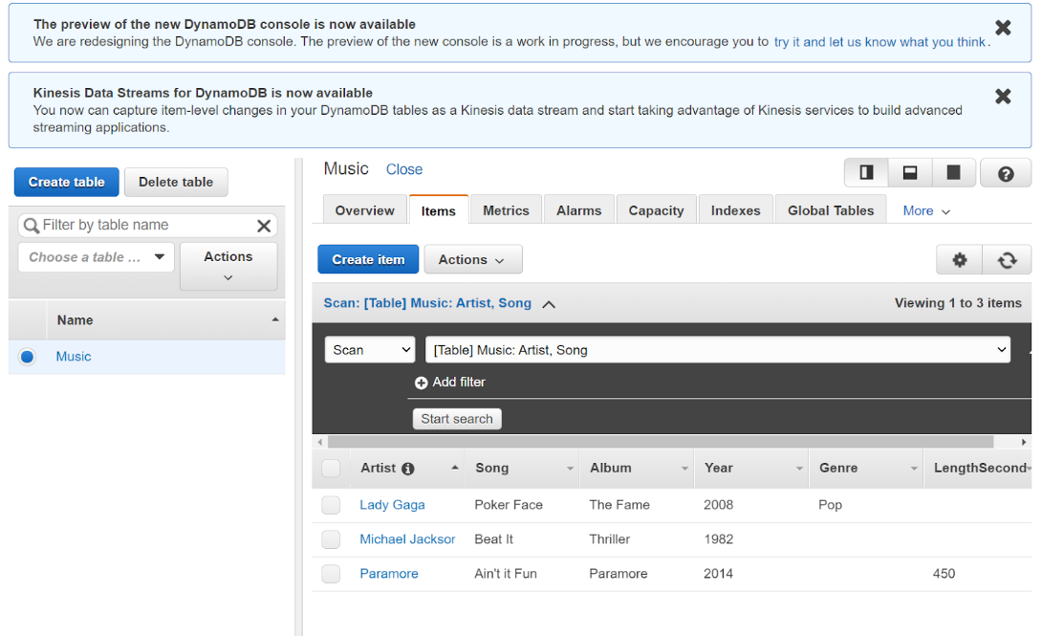

After creating the table, more keys can be added to the table and by adding more attributes to the keys, they have more options with which they can be identified using different features in the table such as scanning.

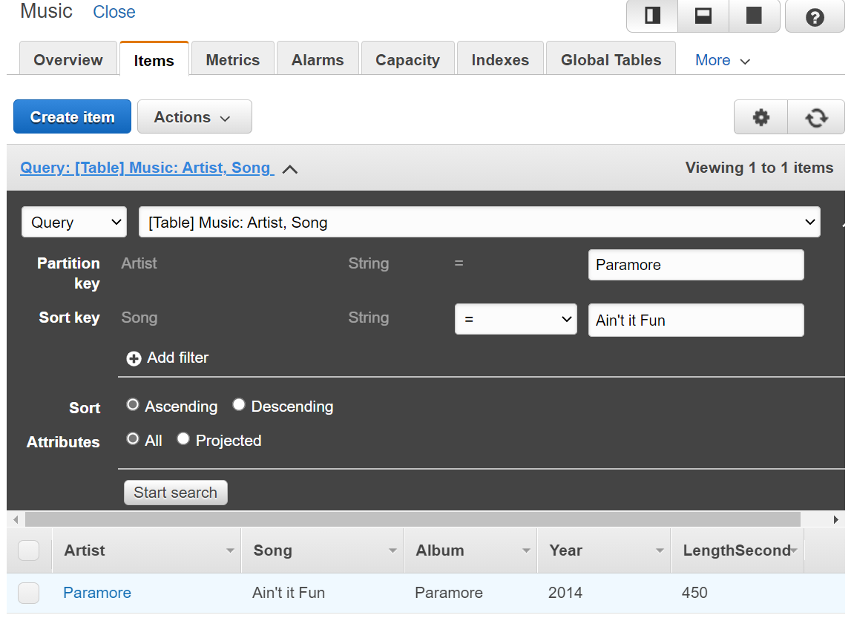

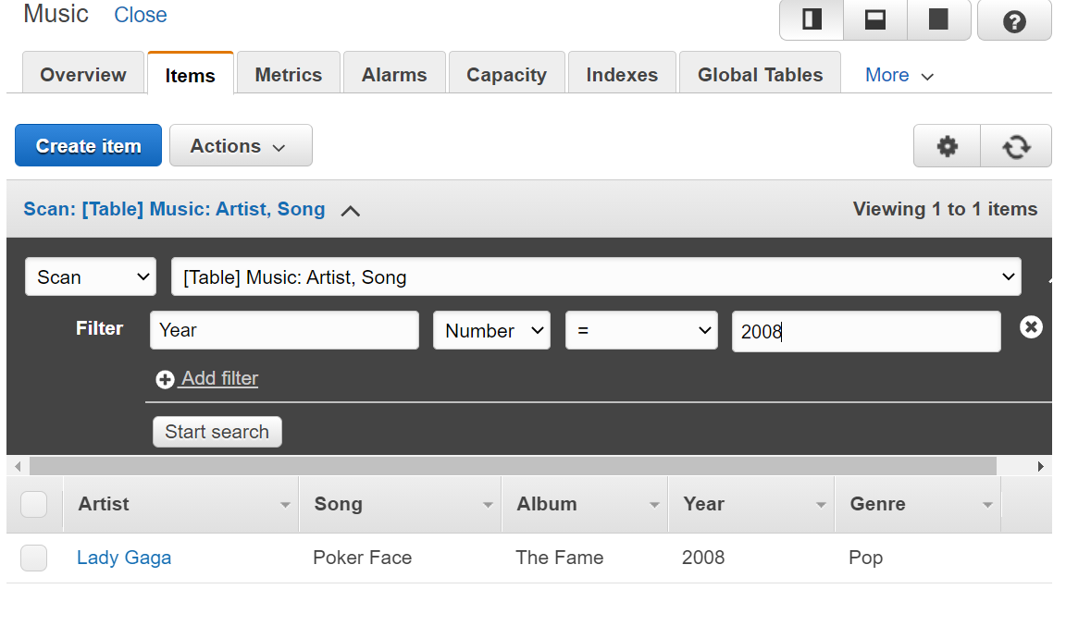

After having different keys and attributes, objects in the table can be found by using a scan or a query.

**Problems**

While creating the keys for the table, if the right setting is not chosen while adding an attribute, the key will give a failure. If the attribute is supposed to be text, it must be a string attribute which will not work with integers.

**Conclusion**

In conclusion, this lab allowed me to explore how to use DynamoDB tables and how to create objects there with different attributes and how to look through the database through different strategies. This gave me an insight on how databases work.